Exercise no : 2 Regno : 1518102098

Date : 15.10.2020

**Aim**

To Write a Python function countX(lst, x) to count the number x in a given list of numbers

**Program**

def countX(lst, x):

count = 0

for ele in lst:

If ele == x:

count = count+1

print(count)

lst =[]

n = int(input())

for i in range(0,n):

ele = int(input())

lst.append(ele)

x = int(input())

countX(lst,x)

**Link**

<http://103.53.53.18/mod/vpl/forms/edit.php?id=230&userid=1703>

**Output**

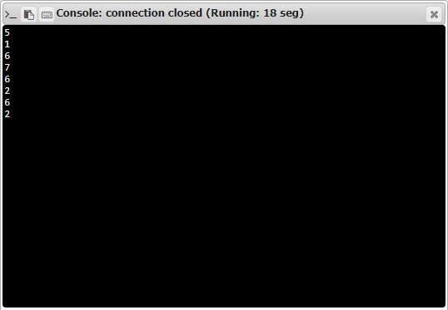

**Result**

Thus,the code has been sucessfully executed and output is verified.